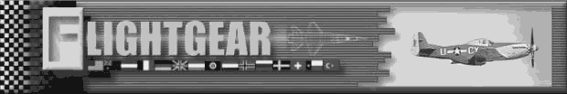

Features:
- The most beautifully rendered, world-wide scenery and most accurate terrain elevation data for any publicly available flight simulator;
- Textures according to land use;
- Correct textures on the runways;
- Accurate positioning of the Sun, Moon and other astronomical objects;
- Navigate with VOR/ADF/DME and fly ILS approaches;
- Network support for multiple players;
- Supports many popular joysticks;
- Several physical flight data models;
- Conversion of 3D plane models;
- Open source: FlightGear is freely available.

What do I need to run FlightGear?
FlightGear runs well enough on a 400MHz Pentium-II machine running Linux or Windows or a comparable Macintosh. However, FlightGear requires a good 3D accelerator card with full OpenGL drivers to achieve smooth frame rates.

How to find more information
The largest source of FlightGear information is our Web Site:
http://www.flightgear.org/

Downloads of FlightGear are available for Windows, UNIX, and Macintosh platforms. Visit
http://www.flightgear.org/Downloads/
for more information.

We can automatically let you know when FlightGear is updated via our mailing lists. To join, check
http://www.flightgear.org/mail.html

HELP WANTED!!
There are many ways to get involved with the FlightGear project. To get started, visit the mailing lists or the “Help Wanted” page on our Web site:
http://www.flightgear.org/Help/

What is FlightGear?
FlightGear is a free flight simulator project. It is being developed through the gracious contribution of source code and spare time by many talented people from around the globe. Among the many goals of this project are the quest to minimize short cuts and "do things right", the quest to learn and advance knowledge, and the quest to have better toys to play with.

The idea for FlightGear was born out of a dissatisfaction with current commercial PC flight simulators. A big problem with these simulators is their proprietary nature and poor extensibility. There are so many people across the world with great ideas for enhancing the currently available simulators, who have the ability to write code, and who have a desire to learn and contribute. Many people involved in education and research could use a spiffy flight simulator framework on which to build their own projects. Unfortunately, commercial simulators do not much lend themselves to modification and enhancement. The FlightGear project strives to fill these gaps.

We have a wide range of people interested and participating in this project. This is truly a global effort with contributors from just about every continent. Interests range from building a realistic home simulator out of old airplane parts, to university research and instructional use, to simply having a viable alternative to commercial PC simulators.

We’ve licensed FlightGear under the Gnu Public License, and thus have intentionally chosen to keep FlightGear and its source code open, available, and free. In doing so, we are able to take advantage of the efforts of tremendously talented people from around the world. Contrast this with the traditional approach of commercial software vendors, who are limited by the collective ability of the people they can hire and pay. Our approach brings its own unique challenges and difficulties, but we are confident (and other similarly structured projects have demonstrated) that in the long run we can outclass our commercial "competition."

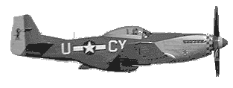
Personally, FlightGear has been a great learning experience for me. I have been exposed to many new ideas and have learned a tremendous amount of "good stuff" in the process of discussing and implementing various FlightGear subsystems. If for no other reason, this alone makes it all worth while.

Curtis Olson,
FlightGear Project Manager

